MONITORING USER’S ACCOUNT
I. Monitoring distributed application components
- Opeeational Health
- Resource utilization
- Application performance

II. Amazon CloudWatch
- Collects and tracks metrics for AWS service across Regions in a metric respiratory
- Collects logs by using Amazon CloudWatch logs
- Supports built-in AWS service metrics or custom metrics
- Calculates statistics from metrics and displays graphs of the metric statistics.
- Provides alarm for responsive event-driven architectures.
- Provides notifications to make changes to monitored resources

III. CloudWatch alarms
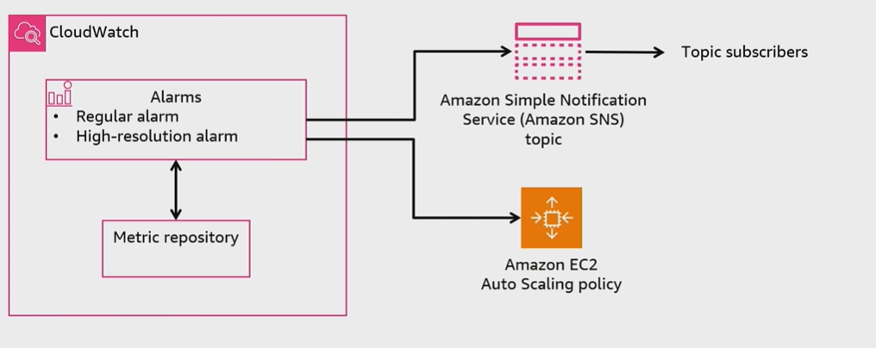

IV. CloudWatch Dashboards
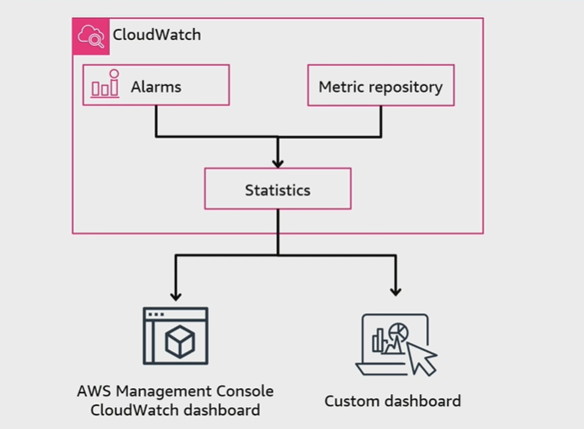
V. EventBridge
- Processes events with an event bus or a pipe:
+ Pipes are point-to-point integrations between one source and one target
+ Event buses are routers that receive events and optionally delivers them to one or multiple targets.
- Makes routing decisions with configurable rules:
+ Rules run based on matching an event pattern or a schedule with Amazon EventBridge Schedular.
+ Targets can be in another AWS account, in another Region, or in both

VI. EventBridge event bus
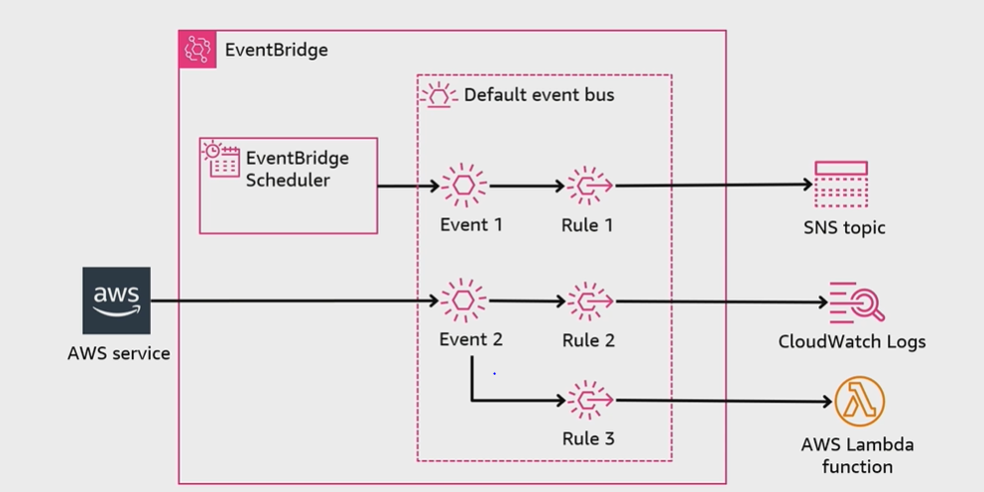
VII. Monitoring resource costs
- AWS Cost Explorer
- AWS Budgets
- AWS Cost and Usage report

